Day4

1: less data

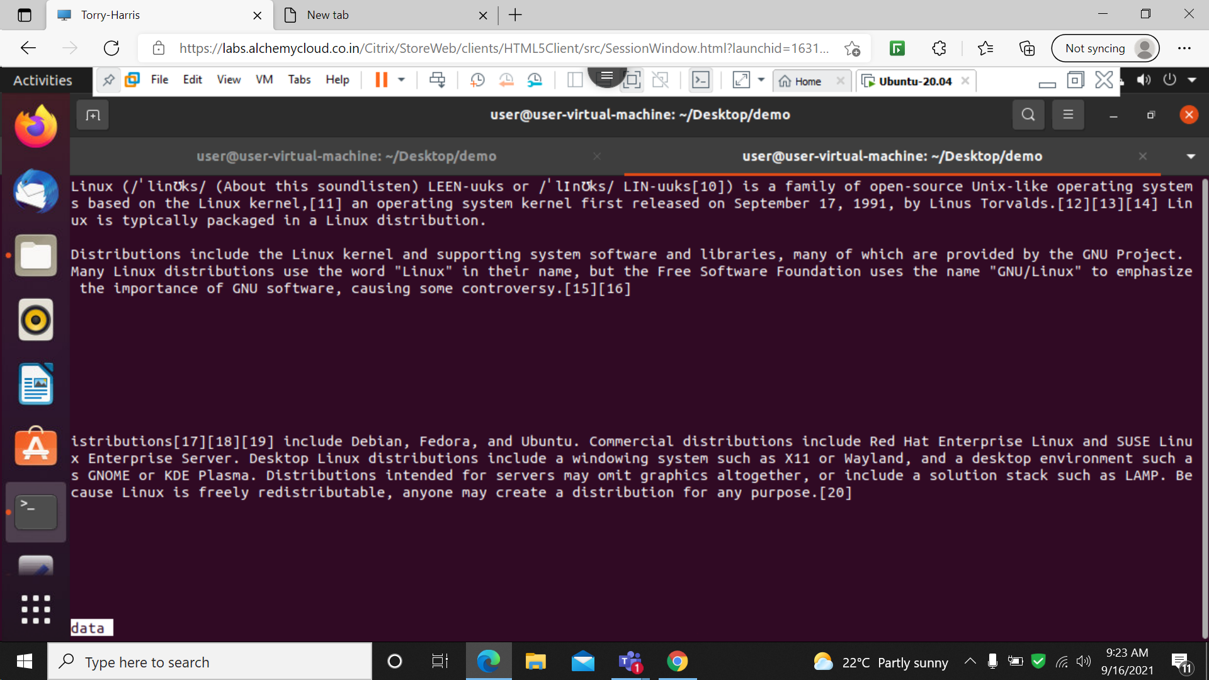

Less command is used to open page by page of a document

2: less –p ‘Linux’ data

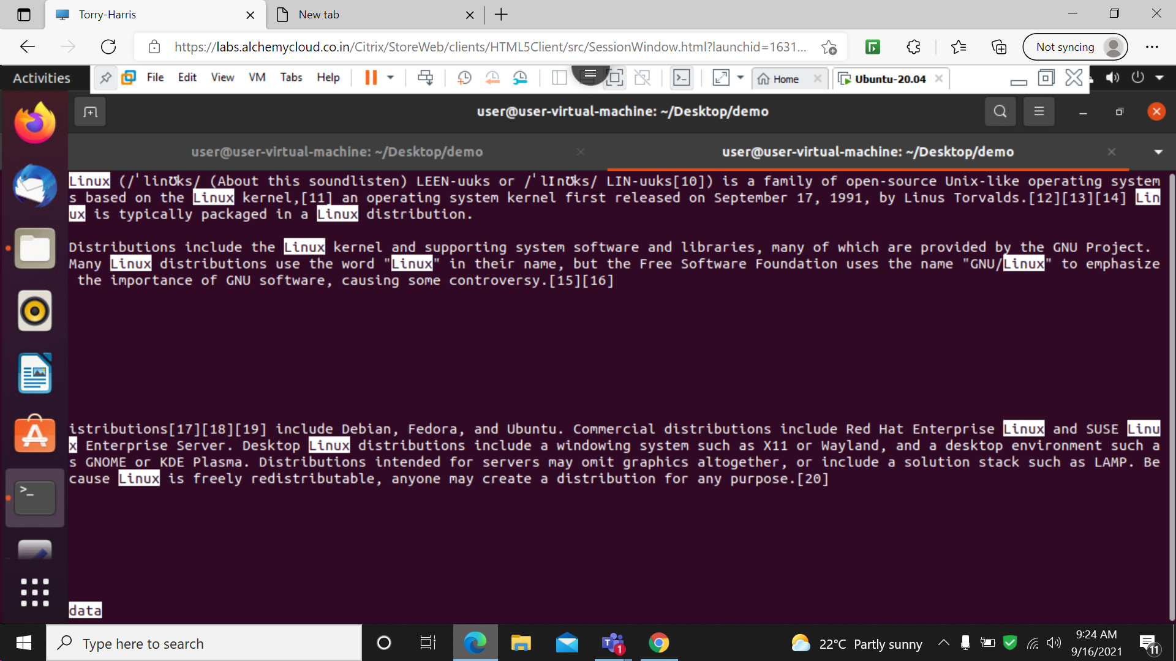

-p is used to search a particular pattern from the file

3: less –N data

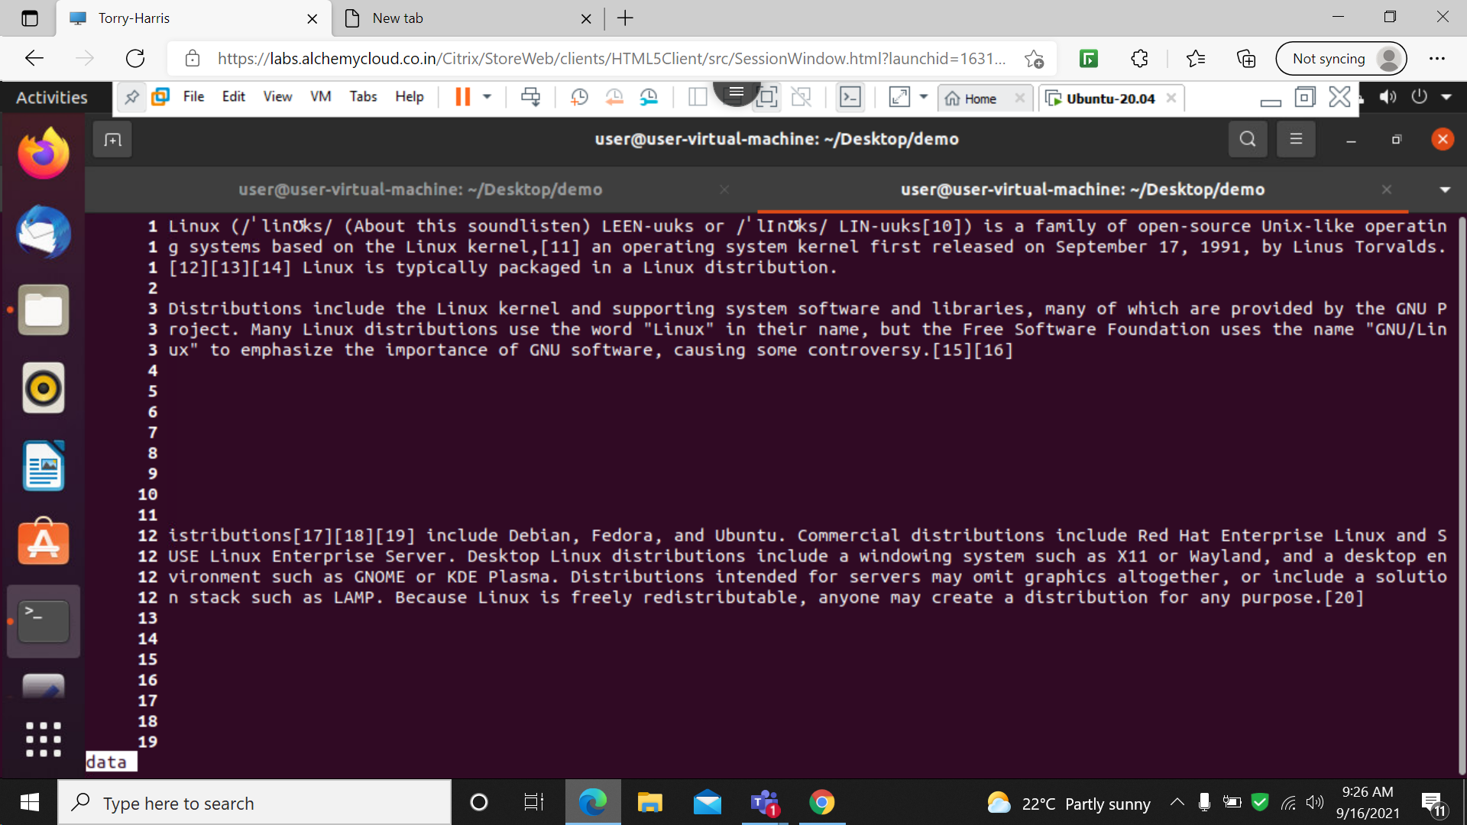

-n command is used to print the line number of the file .

4: which vim

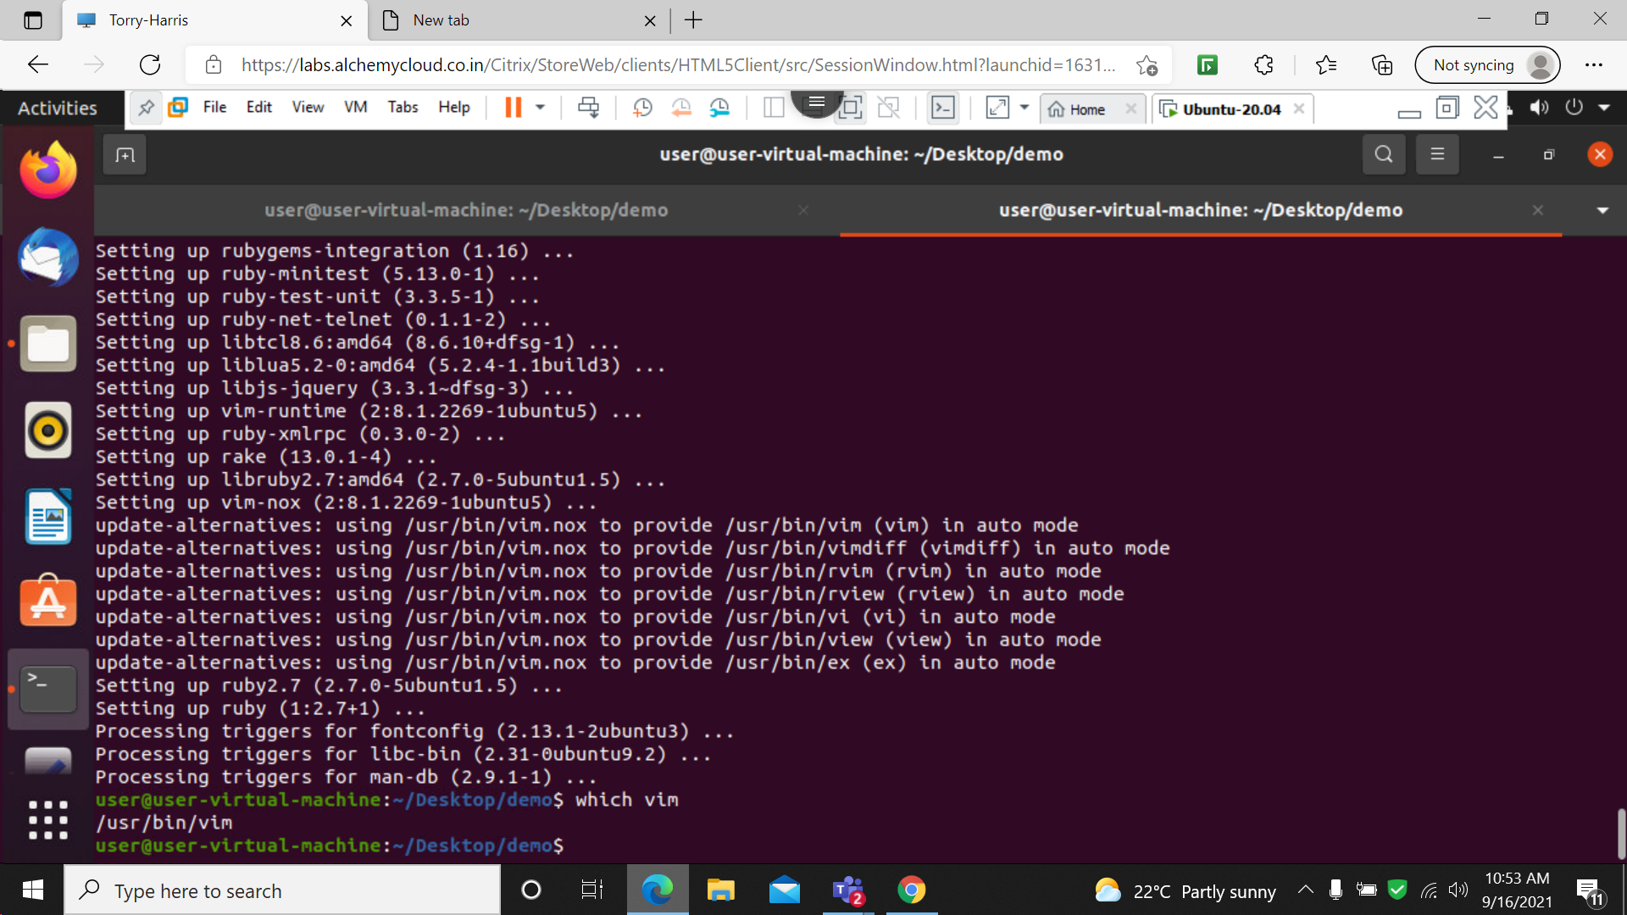

Where the vim is installed in system

5: vim

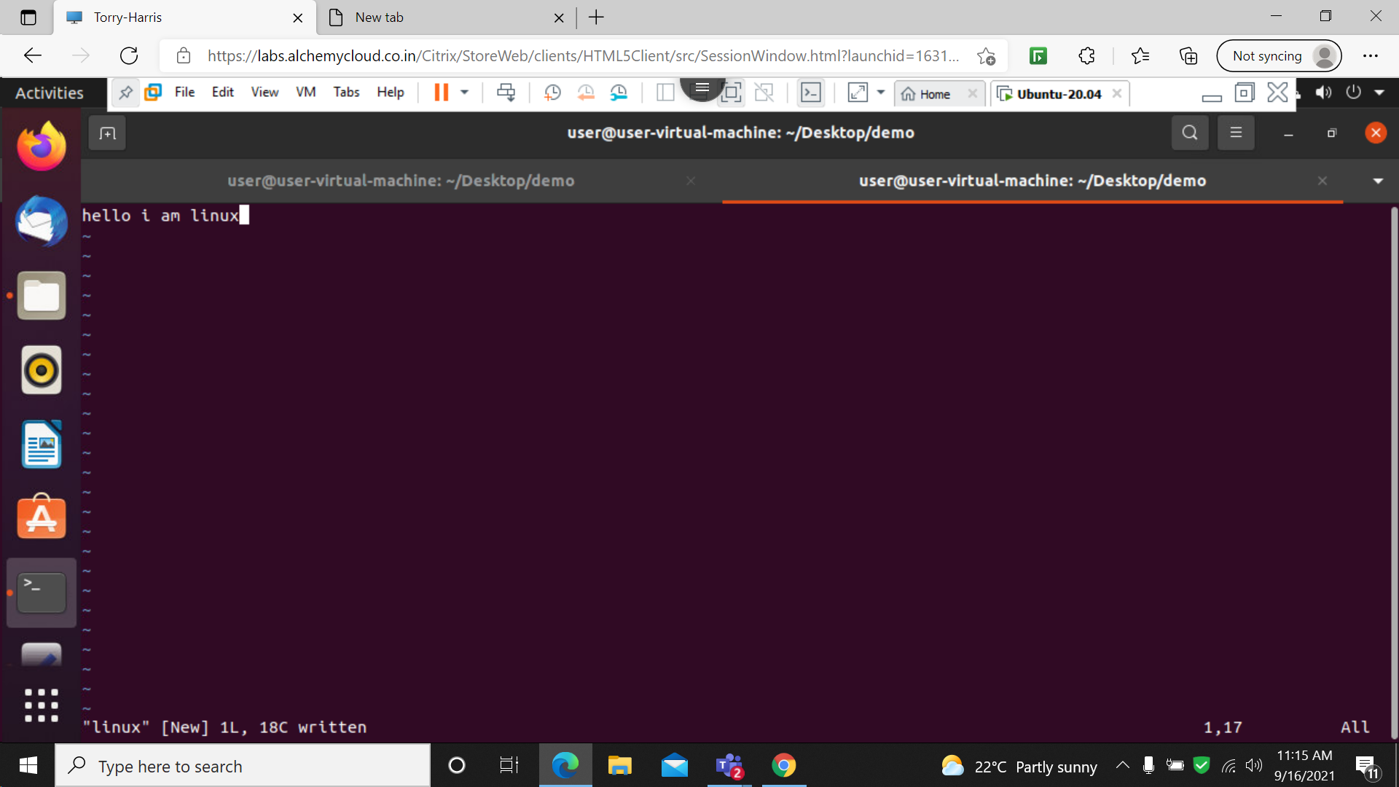

6: add contents to file

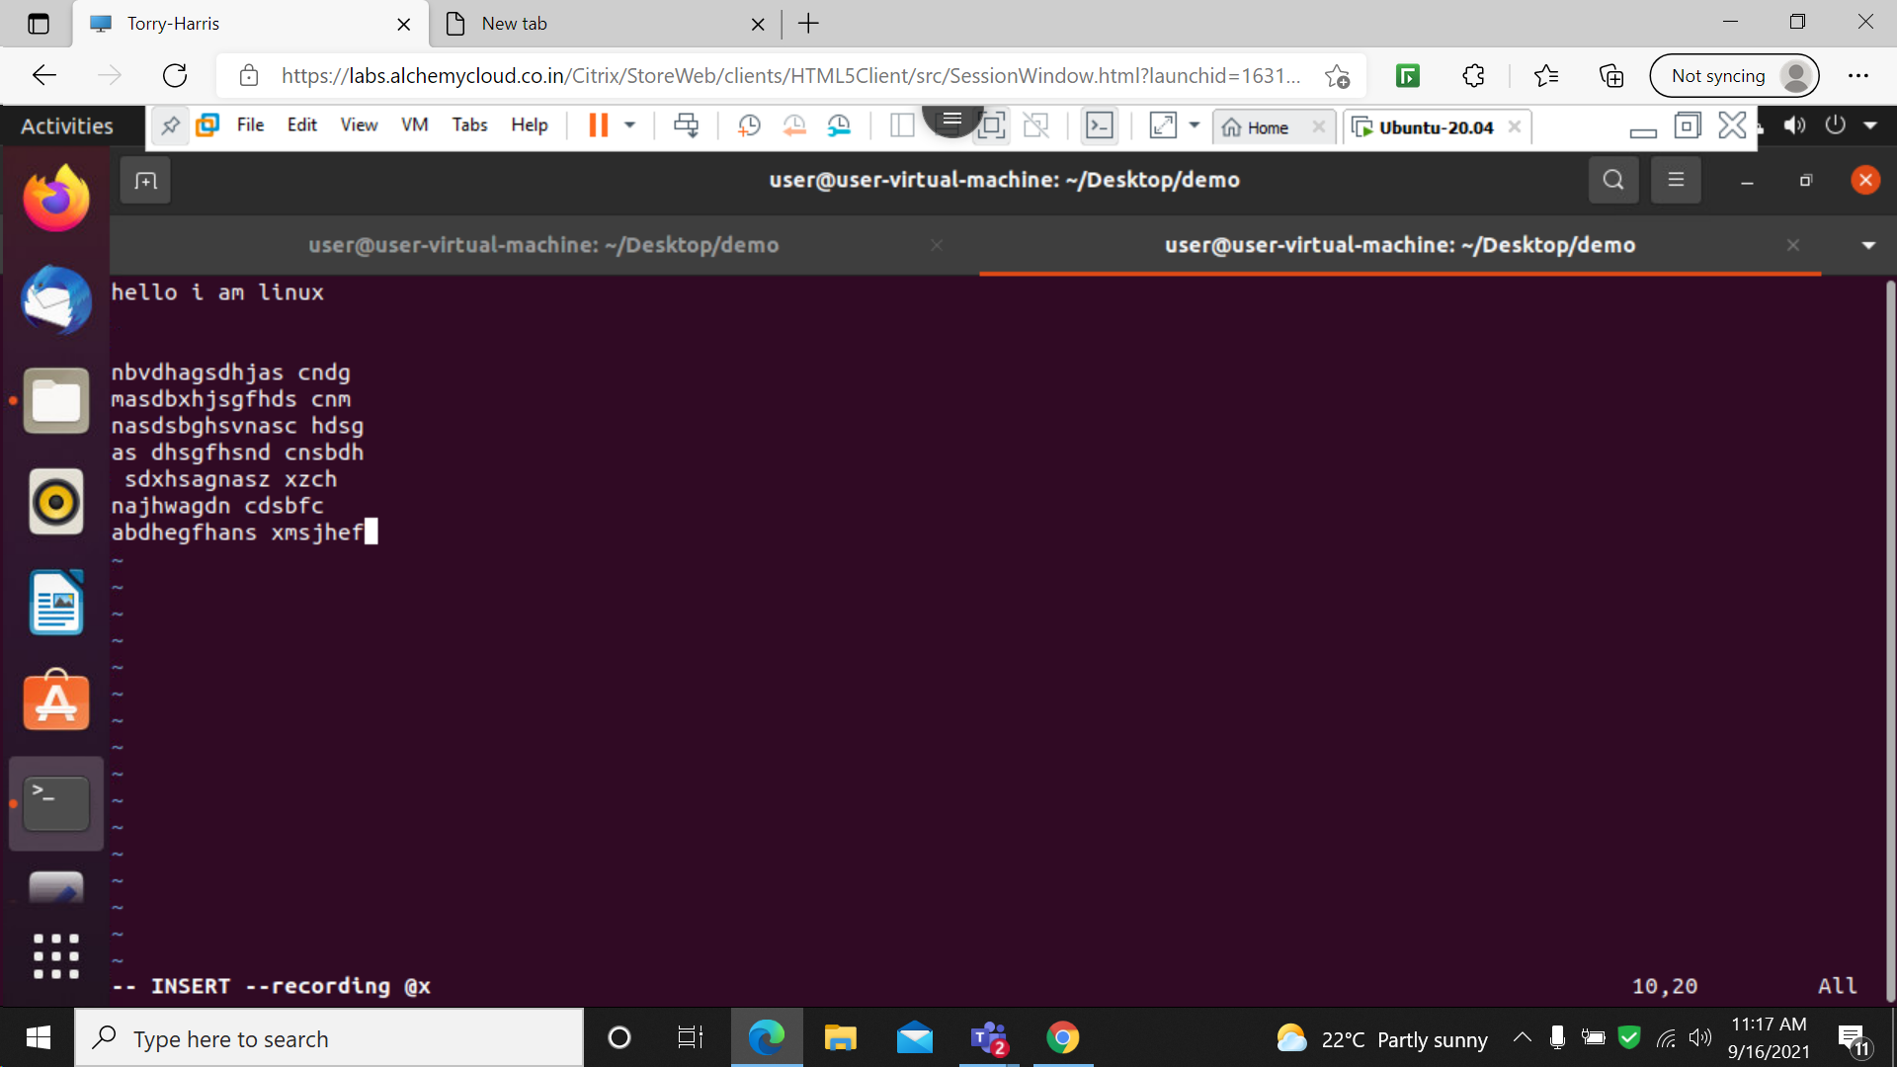

7: dd

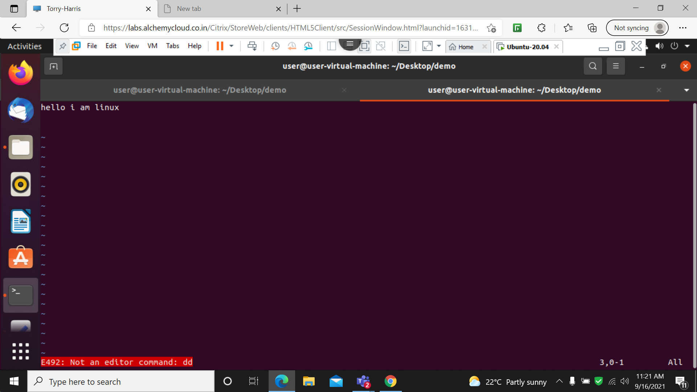

The dd command is used to delete the word line by line .

8: u

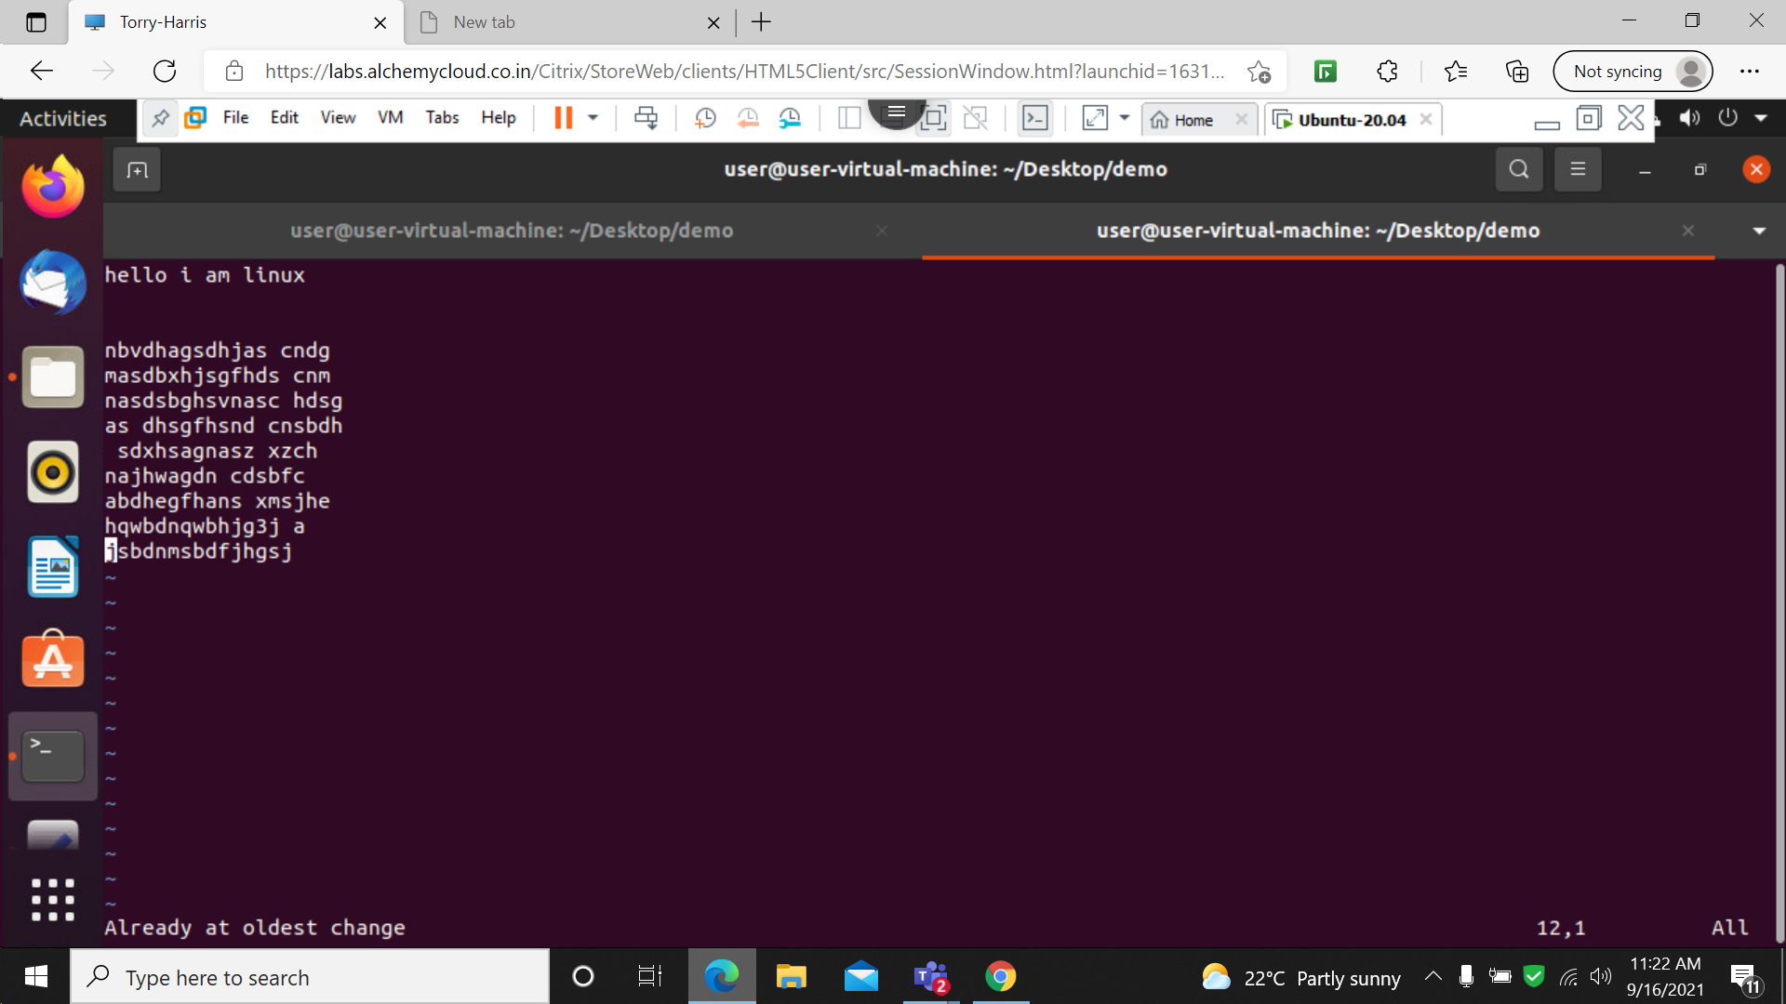

The u command is used to undo the prevoius work in a file

9: x

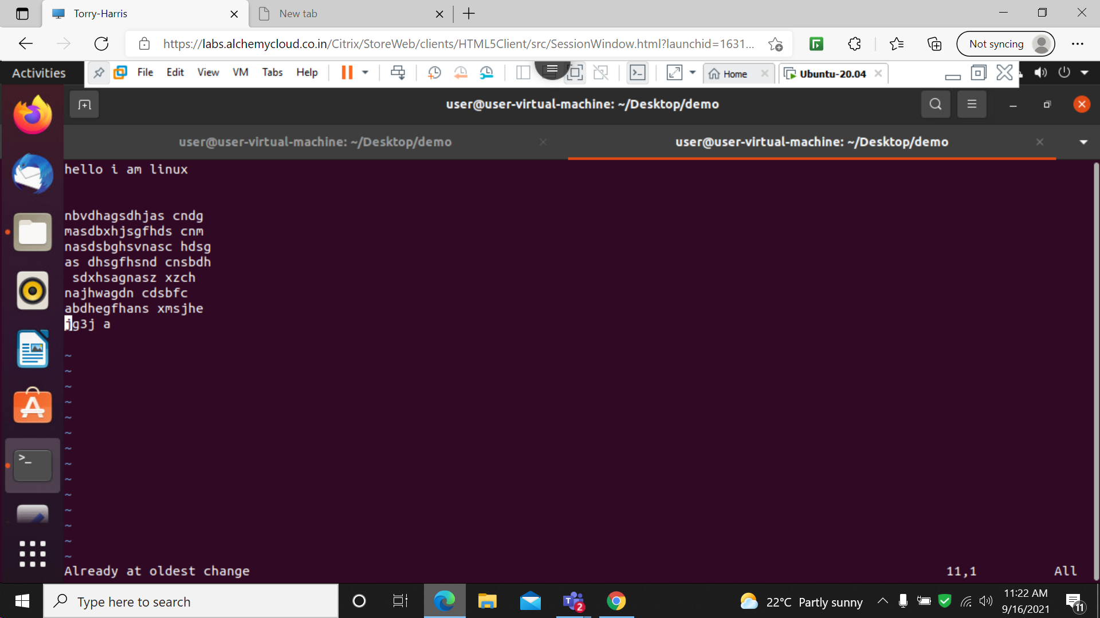

The x command is used to delete word by word /character by character in a file

10: :r

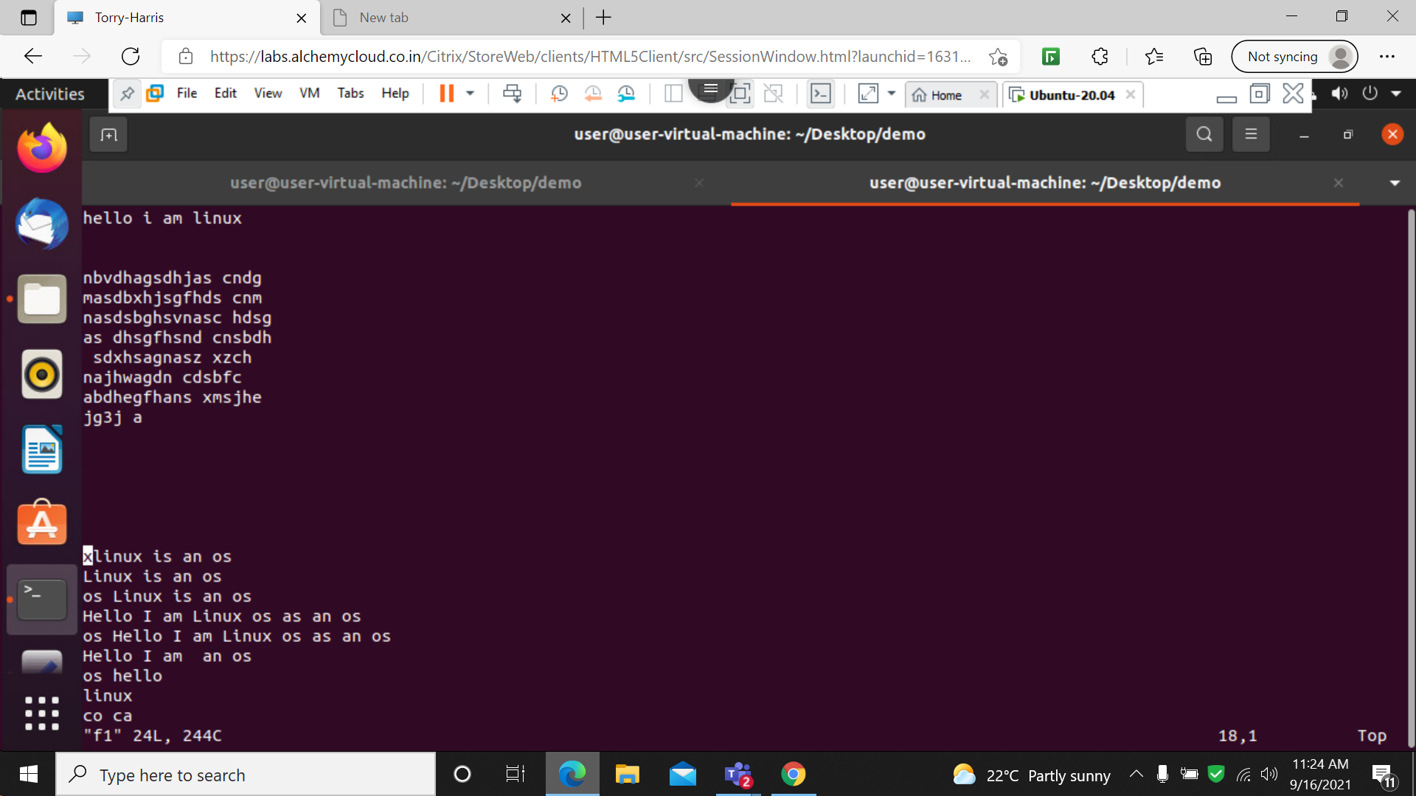

The r command is used to read the existing file

11: : w new

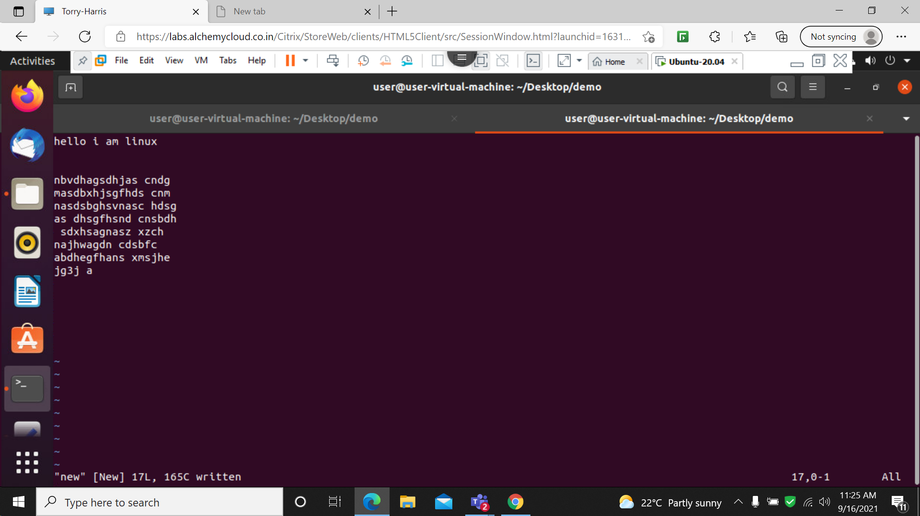

W command is used to write a new file

12: head f1

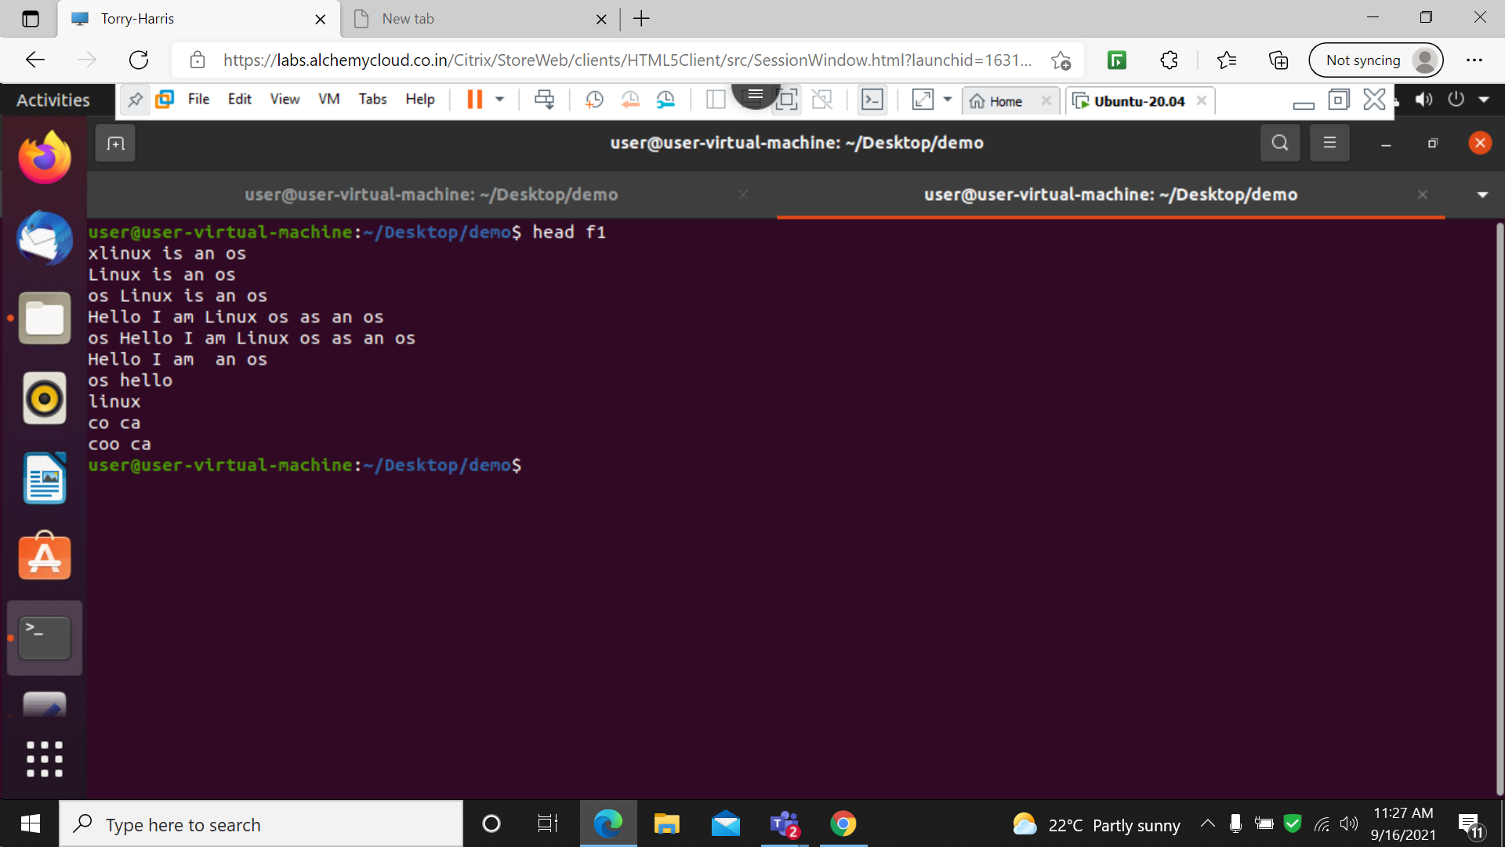

The head command is used to print the first 10 lines of the file .

13: tail f1

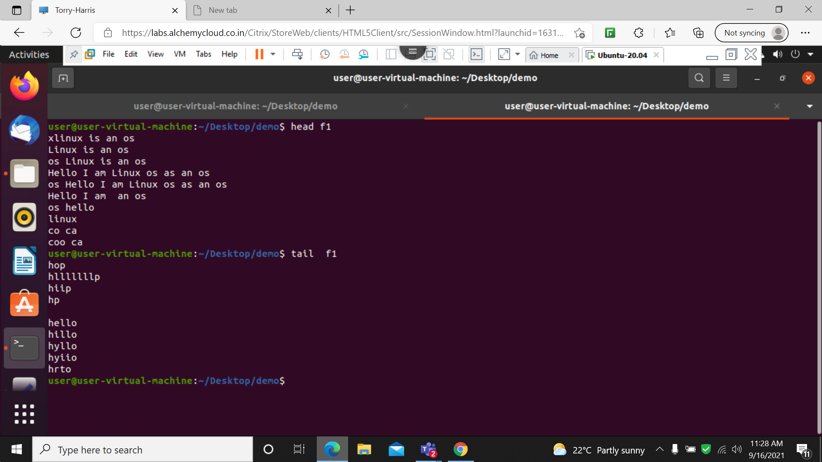

Tail command is used to print the last 10 lines from the file

14: find

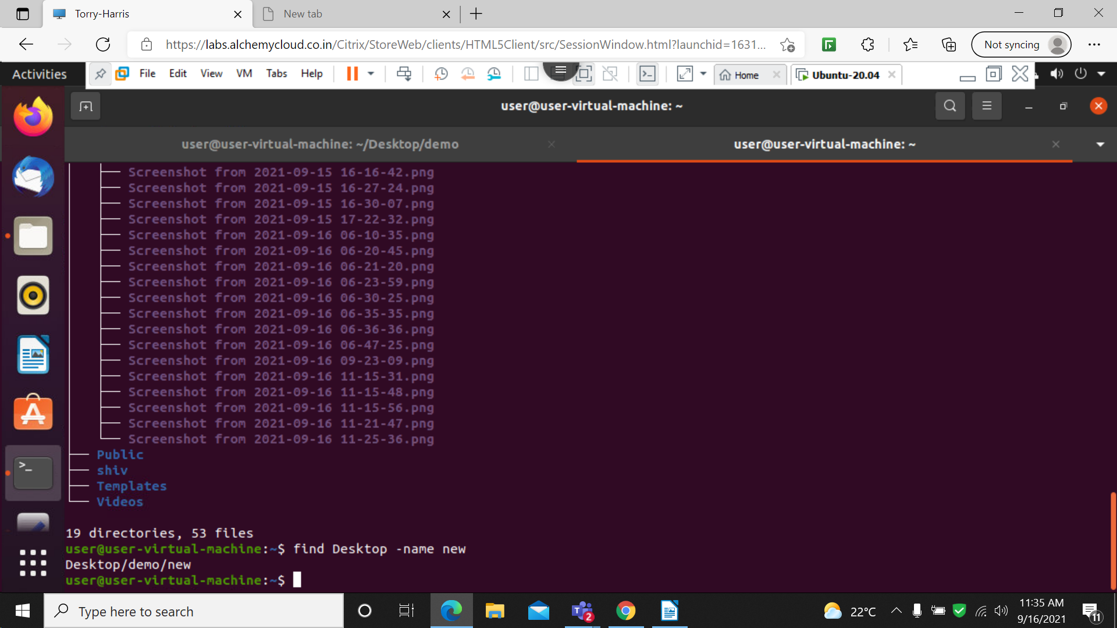

This command is used to find the path of an folder